CHAPTER 4

ANALYSIS AND DESIGN

4.1 System Requirement Analysis
System requirement analysis is the process of identifying the needs and the functionalities that the PSM Assessment System has to provide. The system runs the whole Projek Sarjana Muda lifecycle for PSM 1 and PSM 2 in parallel: title registration, supervisor pairing, the milestone chain, rubric assessment, the decision at the end of a semester, and notification. The analysis in this section covers the system modules, the functional requirements and the non-functional requirements.
Table 4.1: System's Modules
No | Module | Description
1 | Login and Authentication | Authenticates every user with an email address and a password, issues a session token and sends the user to the dashboard for their role. Locks an account after repeated failures.
2 | Title and Registration | Records Lampiran A: the student's particulars, up to three proposed titles and the supervisor they have approached. The supervisor acknowledges the form and chooses the agreed title, which also creates the supervision pairing. Lampiran B then records the project type, field of study and requirements.
3 | Manage Milestone | Generates the milestone chain for a project and opens it one step at a time. A student uploads work to the open milestone and a reviewer approves it or sends it back. Approval is what opens the next milestone.
4 | Manage Evaluation | Lets an assessor mark the form allocated to them on a 0 to 5 scale, converts each item score to the rubric's own weight, and publishes the aggregated mark when the assessor submits.
5 | Generate Report | Produces cohort figures for a batch, a PSM part and a semester, and exports the grade or project list as a CSV file. Every export is recorded in the audit log.
6 | Alert and Notification | Runs the scheduled deadline reminders that go out seven, three and one days before a deadline, and provides the notification centre where a user reads, dismisses or changes which types they receive.

4.1.1 Functional and Non-Functional Requirements
Functional requirements describe what the system should do: the behaviours and services it must provide. Table 4.2 lists them by module.
Non-functional requirements describe how the system performs: the constraints, quality attributes and performance characteristics. Table 4.3 lists them.
Table 4.2: Functional Requirements
No | Module | Requirement
1 | Login | - The system shall authenticate a user with a valid email address and password.
 |  | - The system shall issue a session token and redirect the user to the dashboard for their role.
 |  | - The system shall refuse an unknown account, a wrong password, a locked account and an inactive account with the same message.
 |  | - The system shall lock an account after five failed attempts, and increase the lockout on each repeat.
2 | Registration | - The system shall offer only the academic sessions that are open for registration.
 |  | - The system shall refuse a registration when the student already holds a project, or already has an agreement in flight.
 |  | - The system shall require the supervisor to serve the student's programme, and shall fail open when a programme is not recorded.
 |  | - The system shall accept only a title that the student proposed, so the agreed title and the title put to the panel are the same string.
 |  | - The system shall let a student withdraw a filing until a project has been registered from it.
3 | Milestone | - The system shall generate the milestone chain when a project is registered, and open one milestone at a time.
 |  | - The system shall refuse an upload to a milestone the chain has not opened.
 |  | - The system shall open the next milestone only when the current one is approved.
 |  | - The system shall accept a late upload but flag it as late to the reviewer.
4 | Evaluation | - The system shall present one 0 to 5 score per rubric criterion.
 |  | - The system shall convert each item score to the criterion's weight and total each Lampiran as the form defines it.
 |  | - The system shall refuse a mark before the assessment window for that form is open.
 |  | - The system shall refuse submission while a criterion is unmarked, and shall not treat an unmarked form as zero.
 |  | - The system shall publish the final mark to the student when the assessor submits.
5 | Report | - The system shall produce cohort progress, at-risk students, workload and mark distribution for a batch, part and semester.
 |  | - The system shall export the grade or project list as a CSV file.
 |  | - The system shall record every export in the audit log with its filters.
6 | Notification | - The system shall send a deadline reminder seven, three and one days before a milestone is due.
 |  | - The system shall de-duplicate a reminder so a retried run cannot send it twice.
 |  | - The system shall let a user read, dismiss and change which notification types they receive, except the types the faculty treats as mandatory.

Table 4.3: Non-Functional Requirements
No | Category | Requirement
1 | Security | - Every endpoint shall require an authenticated session token, and every permission shall be checked on the server.
2 | Security | - A password shall be stored only as a hash, and a failure message shall not reveal whether an account exists.
3 | Auditability | - Every state change that affects a grade, a title or a pairing shall be written to the audit log with its actor, time and before/after values.
4 | Data integrity | - A mark shall be computed, never typed in as a final result, so the aggregate and the components cannot disagree.
5 | Performance | - A list of a full cohort shall load within two seconds, and a 26-project cohort shall be listed without a per-row query.
6 | Availability | - Uploaded evidence shall be stored outside the application container so it survives a redeploy.
7 | Usability | - Every refusal shall name its cause rather than returning a generic failure.
8 | Portability | - The system shall run in a browser with no client installation.

4.2 System Analysis
The system has six use cases. Three of the actors are operational — the student, the supervisor and the coordinator — and two are administrative: the lecturer, who marks coursework for one teaching section, and the administrator, who configures the system. An examiner is not a role but a seating: a member of staff is put on a project's panel, and that is what gives them the evaluation form.

4.2.1 Use Case Diagram
Figure 4.1 shows the use cases and the actors that reach them. A student reaches title and registration, milestones and their own marks; a supervisor reaches the acknowledgement, the milestone review, the evaluation and the reports; a coordinator reaches the reports and the notifications in addition.
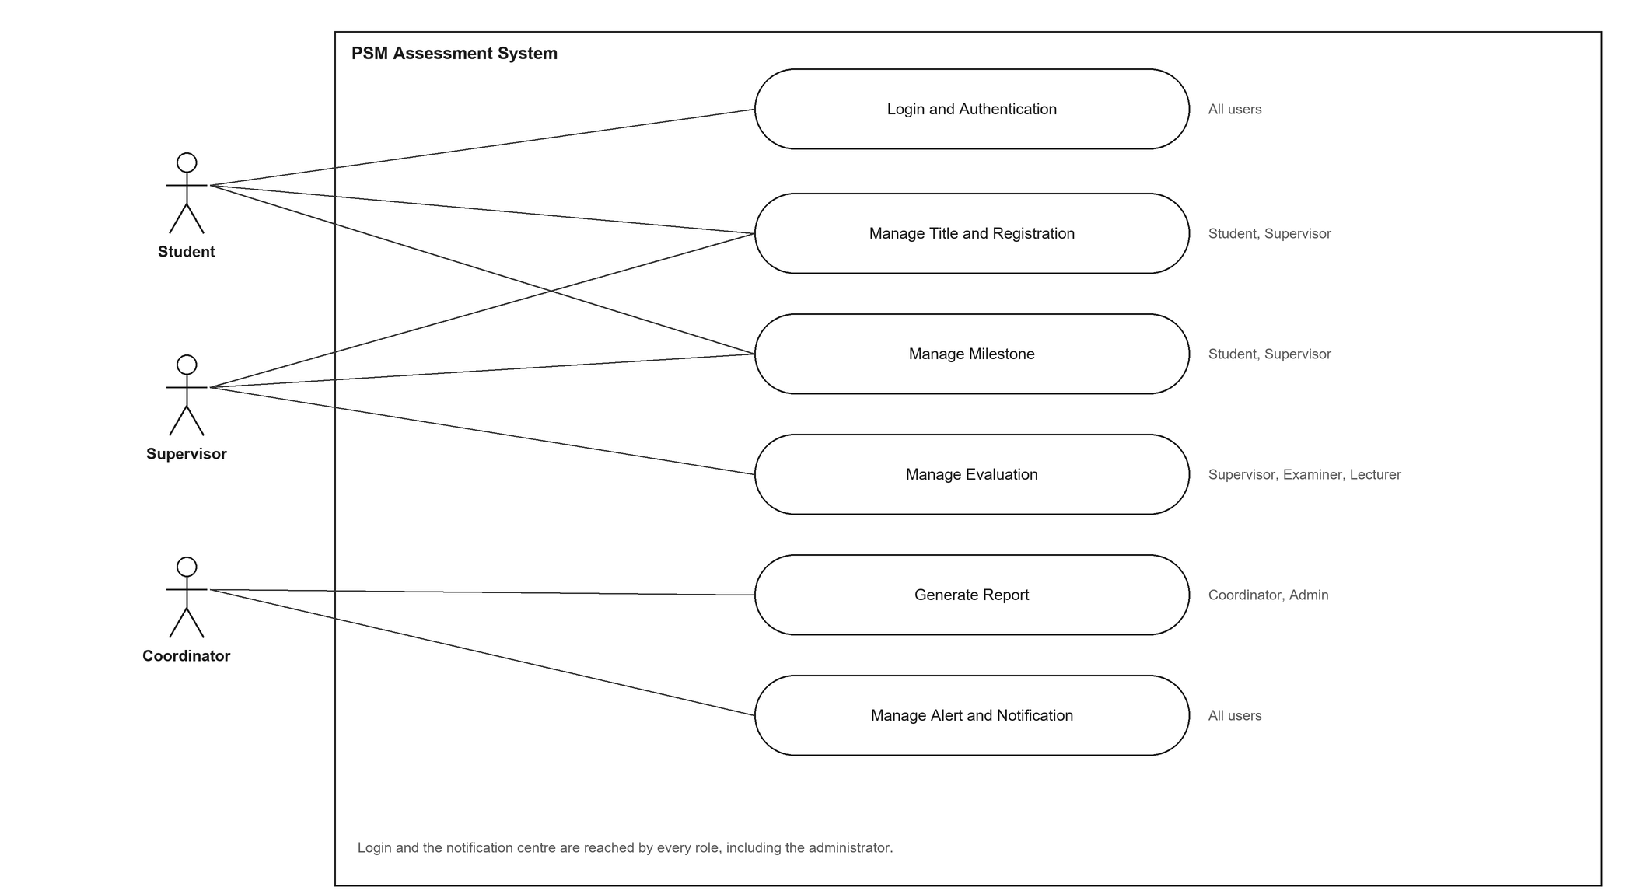
Figure 4.1: Use Case Diagram

4.2.2 Use Case Specification
This section specifies each use case in turn. Every specification carries its history log, its actors, its normal flow, its alternative flows and the requirement it satisfies, and each is followed by the sequence diagram and the activity diagram for the same use case.
(i) Use Case 1: Login and Authentication
Table 4.4 shows the specification for Login and Authentication. The use case lets any user prove who they are and reach the screens their role allows.
Table 4.4: Login and Authentication Use Case Specification
History Log | 1.0.0 Create initial use case.  2.0.0 Add account lockout and the audit entry.
Version | 2.0.0
Use Case ID | UC-01
Use Case Name | Login and Authentication
Actors | Student, Supervisor, Lecturer, Coordinator, Admin.
Description | The user signs in with an email address and a password. The system checks the credentials, and either issues a session token and sends the user to the dashboard for their role, or refuses the attempt.
Preconditions | The user holds an account, and the account is active.
Post conditions | The user is signed in and holds a session token, or remains on the login form and the attempt is recorded.
Normal Flow | 1. The user opens the login page.  2. The user enters their email address and password.  3. The system checks that both fields are present and that the address is well formed.  4. The system finds the account and verifies the password against its hash.  5. The system confirms that the account is not locked and is active.  6. The system creates a session token and resets the failed attempt counter.  7. The system records the sign-in in the audit log.  8. The system sends the user to the dashboard for their role.
Alternative Flow | A1. Missing or malformed input: the system returns a validation error and the user corrects it.  A2. Unknown account: the attempt is recorded and the general failure message is shown.  A3. Account locked after repeated failures: the attempt is refused until the lock expires.  A4. Wrong password: the counter increases, and the same general message is shown.  A5. Account inactive or suspended: the attempt is refused.
Exceptions | E.1 The credential check fails for any reason: the system shows the same message for an unknown account and a wrong password, so the form cannot be used to discover which addresses exist.

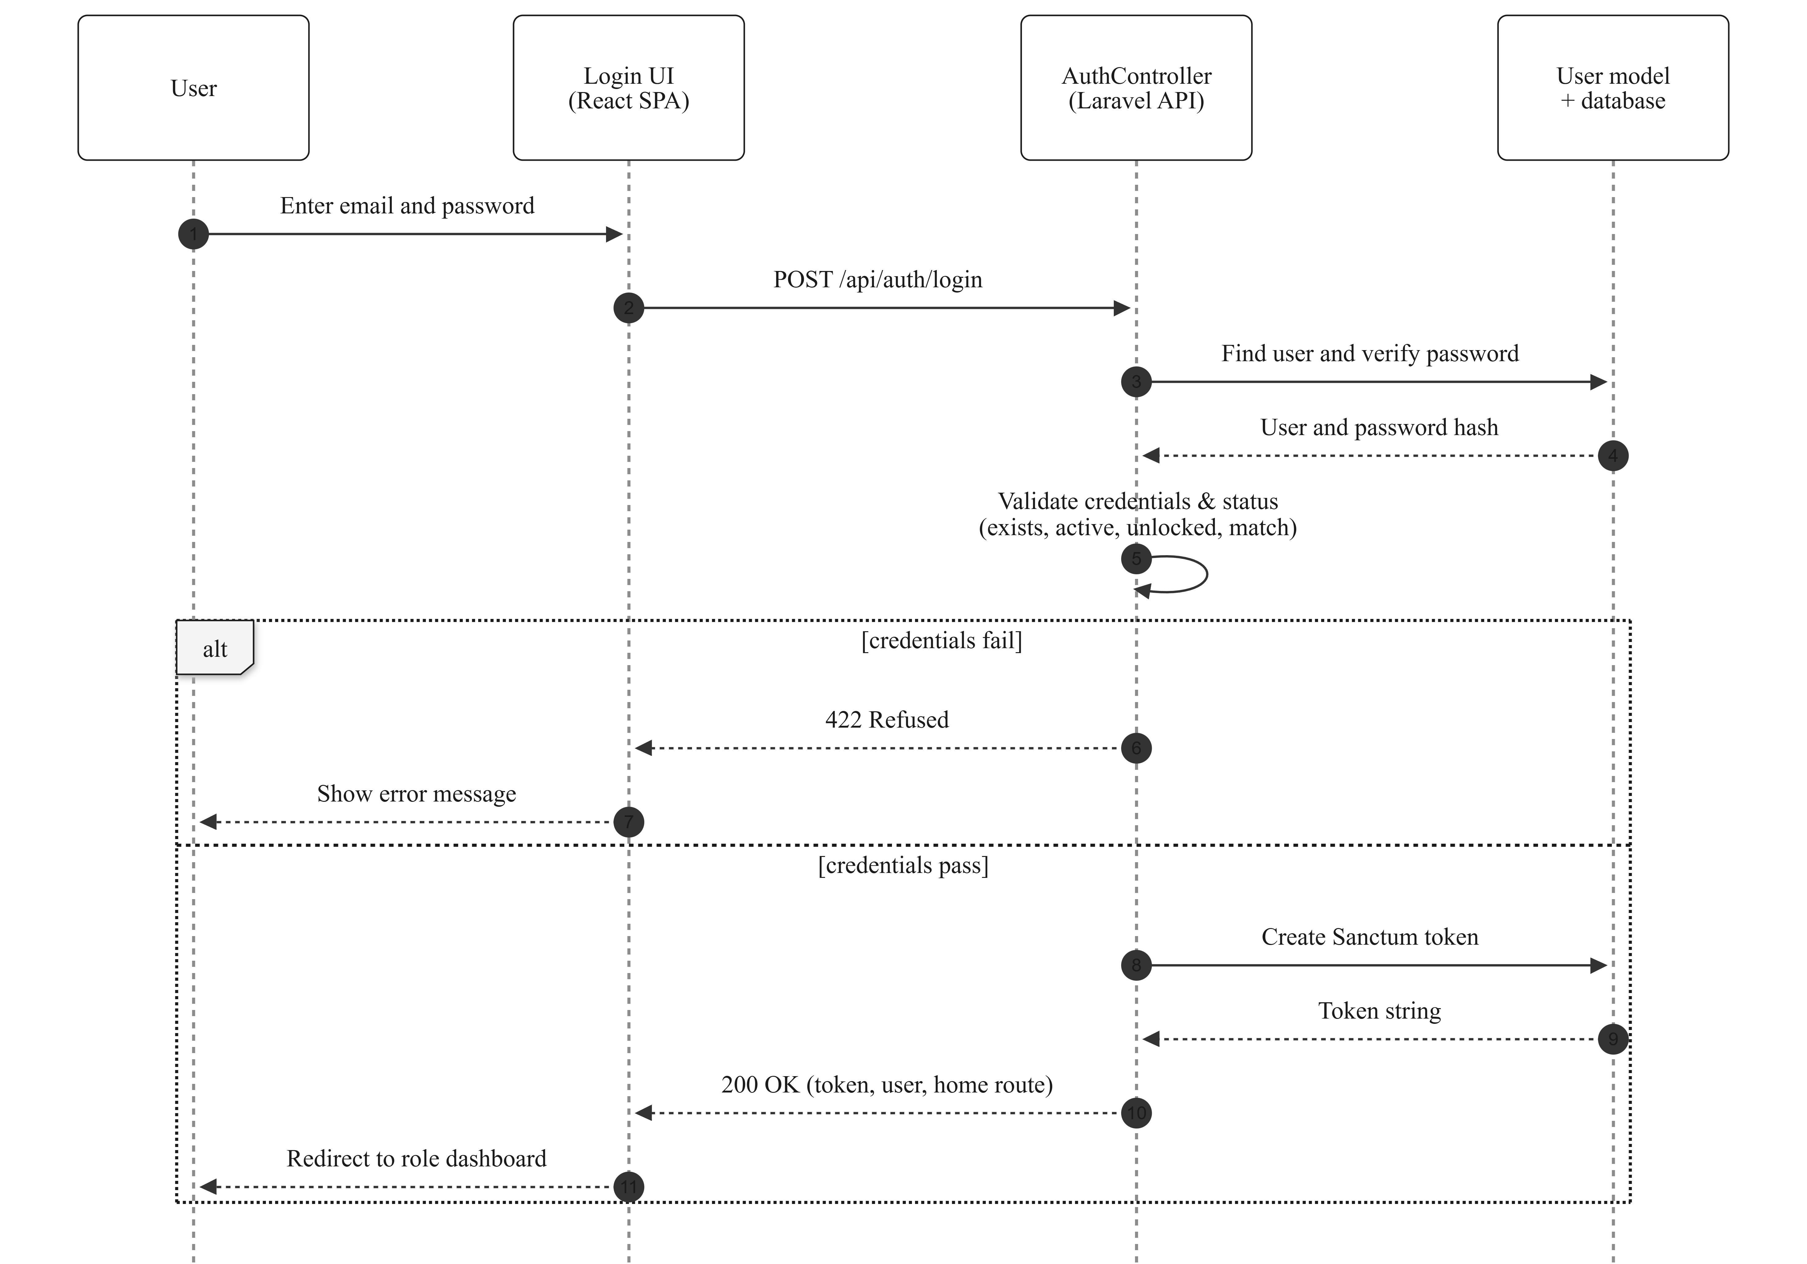
Figure 4.2: Sequence Diagram for Login and Authentication
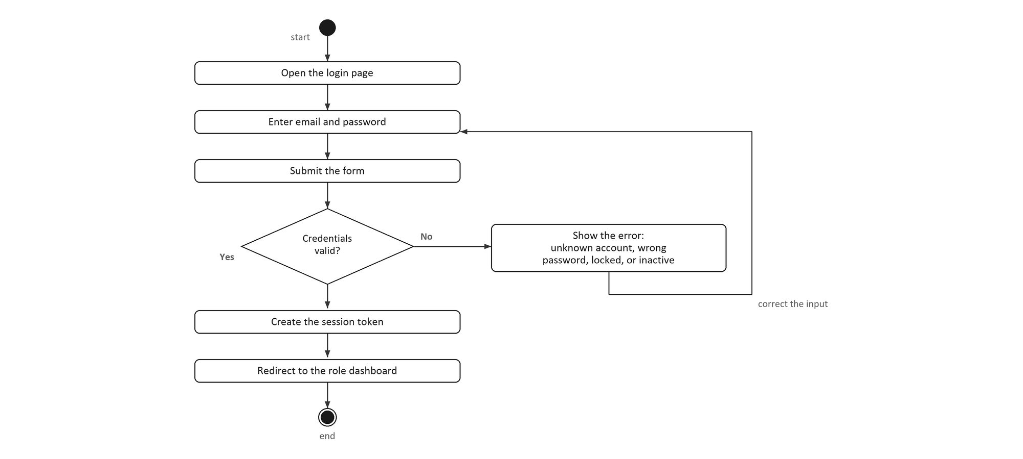
Figure 4.3: Activity Diagram for Login and Authentication
(ii) Use Case 2: Manage Title and Registration
Table 4.5 specifies Manage Title and Registration. The use case is the only route by which a title enters the system and the only route by which a supervision is created: the student files Lampiran A, the supervisor acknowledges it and chooses which of the proposed titles will be registered, and Lampiran B records the requirements before the supervisor signs it.
Table 4.5: Manage Title and Registration Use Case Specification
History Log | 1.0.0 Create initial use case.  2.0.0 Lampiran B becomes a record, and a refused title is re-presented.
Version | 2.0.0
Use Case ID | UC-02
Use Case Name | Manage Title and Registration
Actors | Student (primary, for Lampiran A and Lampiran B), Supervisor (primary, for the acknowledgement and the signature). Coordinator and Admin may view and audit.
Description | The student registers for PSM 1 by filing Lampiran A, which records their particulars, up to three proposed titles and the supervisor they have approached. The supervisor acknowledges the agreement and, in doing so, chooses which of the three titles the student will register; the acknowledgement is also the moment the supervision is created. The student then files Lampiran B, which records the project type, the field of study and the software, hardware and technology the project requires, and the supervisor signs it. Signing opens the proposal milestone.
Preconditions | The student is signed in and an academic term is open for registration. The student holds no project and no agreement in flight for that term. The named supervisor serves the student's programme and has capacity for the part.
Post conditions | The student holds an approved agreement naming one agreed title, a supervision exists, and the proposal milestone is open. The project's title is not fixed here: it becomes the project's title only when a panel accepts it.
Normal Flow | 1. The student opens Lampiran A and selects the session from the list of open terms.  2. The student enters their particulars and proposes up to three titles.  3. The student names a supervisor and submits the form.  4. The system confirms that a term is open, and that the student holds no project and no agreement.  5. The system validates each proposed title.  6. The system confirms that the supervisor serves the student's programme.  7. The system creates the agreement with the status pending supervisor and notifies the supervisor.  8. The supervisor opens the agreement and chooses one of the proposed titles.  9. The system confirms the chosen title is one the student proposed.  10. The system creates the supervision and records the agreed title.  11. The student files Lampiran B.  12. The supervisor signs the form, which opens the proposal milestone.
Alternative Flow | A1. No term is open, a project already exists, or an agreement is already in flight: the system refuses the filing and names which of the three applies.  A2. A proposed title is unusable: the system refuses it and the student corrects it.  A3. The supervisor does not serve the student's programme: the submission is refused. An unrecorded programme is allowed through, so legacy staff rows are not locked out.  A4. The supervisor names a title the student did not propose: the system refuses it, because the acknowledgement is a choice between the candidates.  A5. The supervisor sends Lampiran B back instead of signing: the form returns to the student as a draft with a reason.  A6. The student withdraws the filing before a project is registered from it: the agreement is cancelled, the supervision is retired and the pending form is cleared.  A7. A project has already been registered: withdrawal is refused and unwinding it becomes a coordinator decision.
Exceptions | E.1 A title refused by the panel is re-presented on a new Lampiran B, which needs a new signature: a signature on one title does not cover another. Nothing is overwritten, so the refusal stays on record.

Figure 4.4: Sequence Diagram for Manage Title and Registration
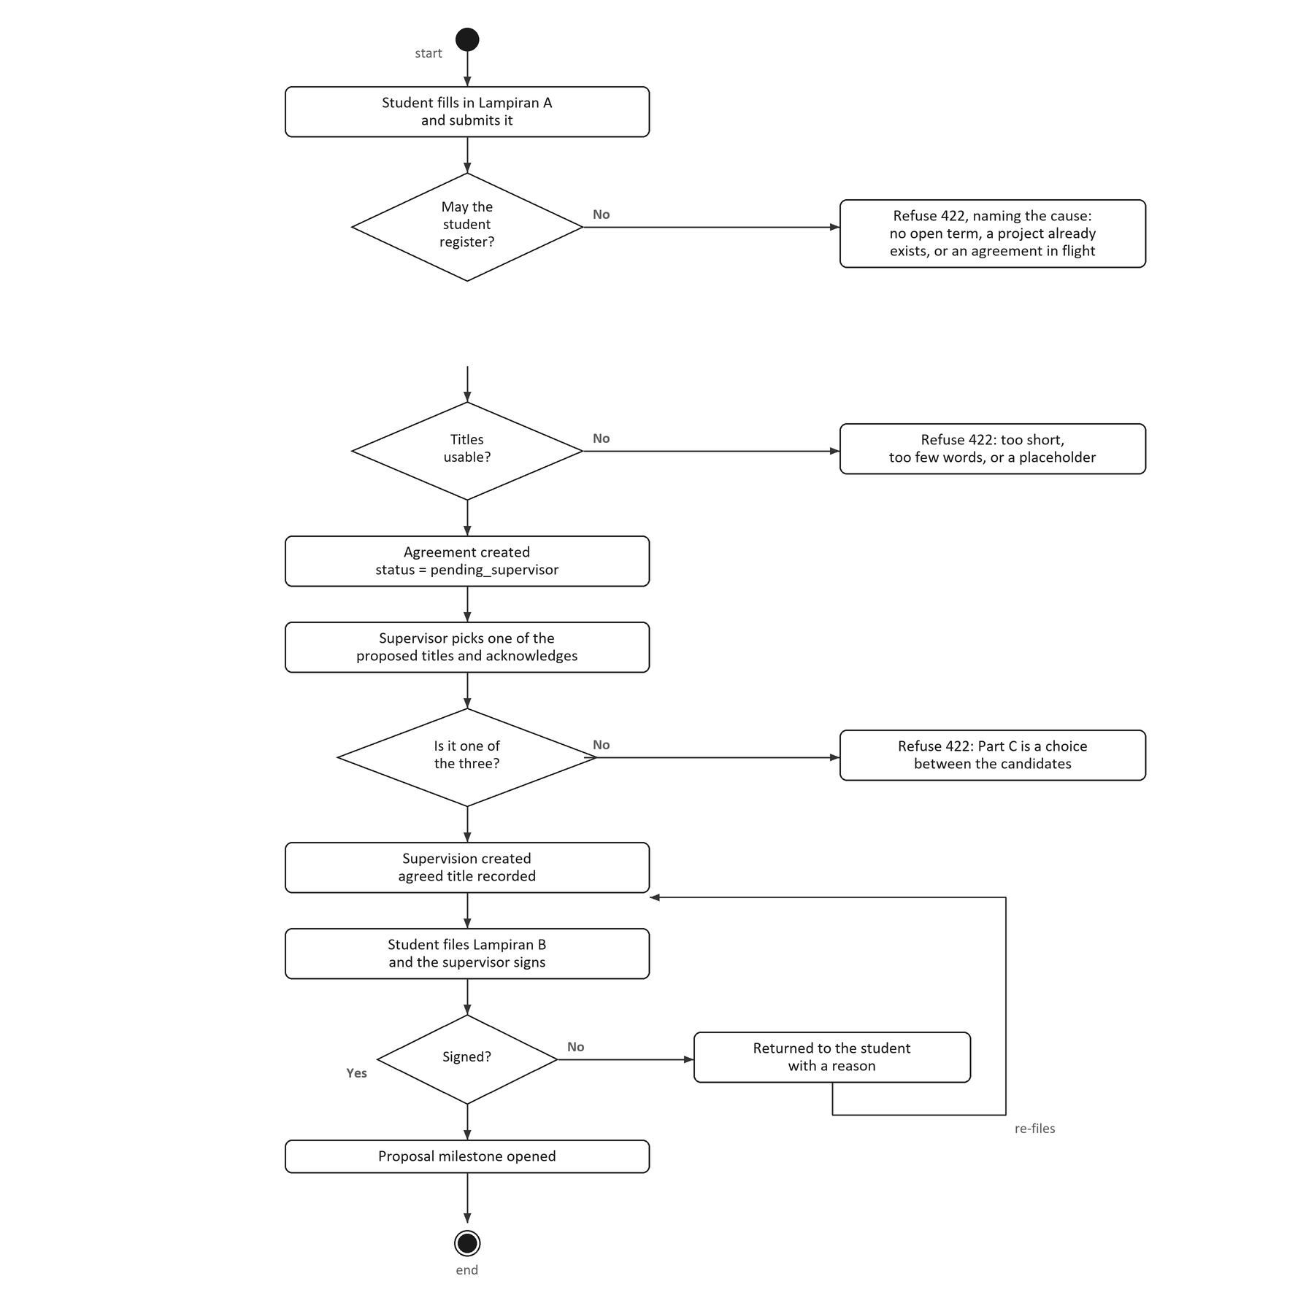
Figure 4.5: Activity Diagram for Manage Title and Registration
(iii) Use Case 3: Manage Milestone
Table 4.6 specifies Manage Milestone. The rule the use case turns on is that approving a milestone is what opens the next one, so the chain cannot run ahead of the work.
Table 4.6: Manage Milestone Use Case Specification
History Log | 1.0.0 Create initial use case.  2.0.0 The supervisor endorses the proposal before the panel sees it.
Version | 2.0.0
Use Case ID | UC-03
Use Case Name | Manage Milestone
Actors | Student (submits), Supervisor (reviews), Coordinator and Admin (review, deadline), Panel (the proposal's verdict).
Description | The system generates a milestone chain for a project and opens its milestones in order. A student submits work to the open milestone and a reviewer approves it or requests a revision. Approval opens the next milestone; a revision request reopens the same one.
Preconditions | The project is registered, its chain has been generated, and the milestone is open.
Post conditions | The milestone is approved and the next one is open, or it has been returned to the student with the revision count increased.
Normal Flow | 1. The coordinator registers the project and the chain is generated.  2. The first milestone is opened.  3. The student uploads the work.  4. The system confirms that the chain has opened the milestone.  5. The supervisor opens the submitted work.  6. The supervisor approves it or requests a revision.  7. The system confirms that the actor may review the milestone and that the status allows the move.  8. The system saves the status, the reviewer and the comment.  9. The system opens the next milestone in the chain.  10. The system notifies the student.
Alternative Flow | A1. The upload reaches a milestone the chain has not opened: the system refuses it.  A2. The supervisor requests a revision: the status becomes rejected, the revision counter increases, and the milestone reopens for a new upload.  A3. The supervisor sends the proposal back: the same transition is used, and the chain does not advance.  A4. The milestone is the proposal: approving it does not open the chain, because its verdict belongs to the panel.
Exceptions | E.1 No milestone remains after an approval: the project is recorded as complete for that part.

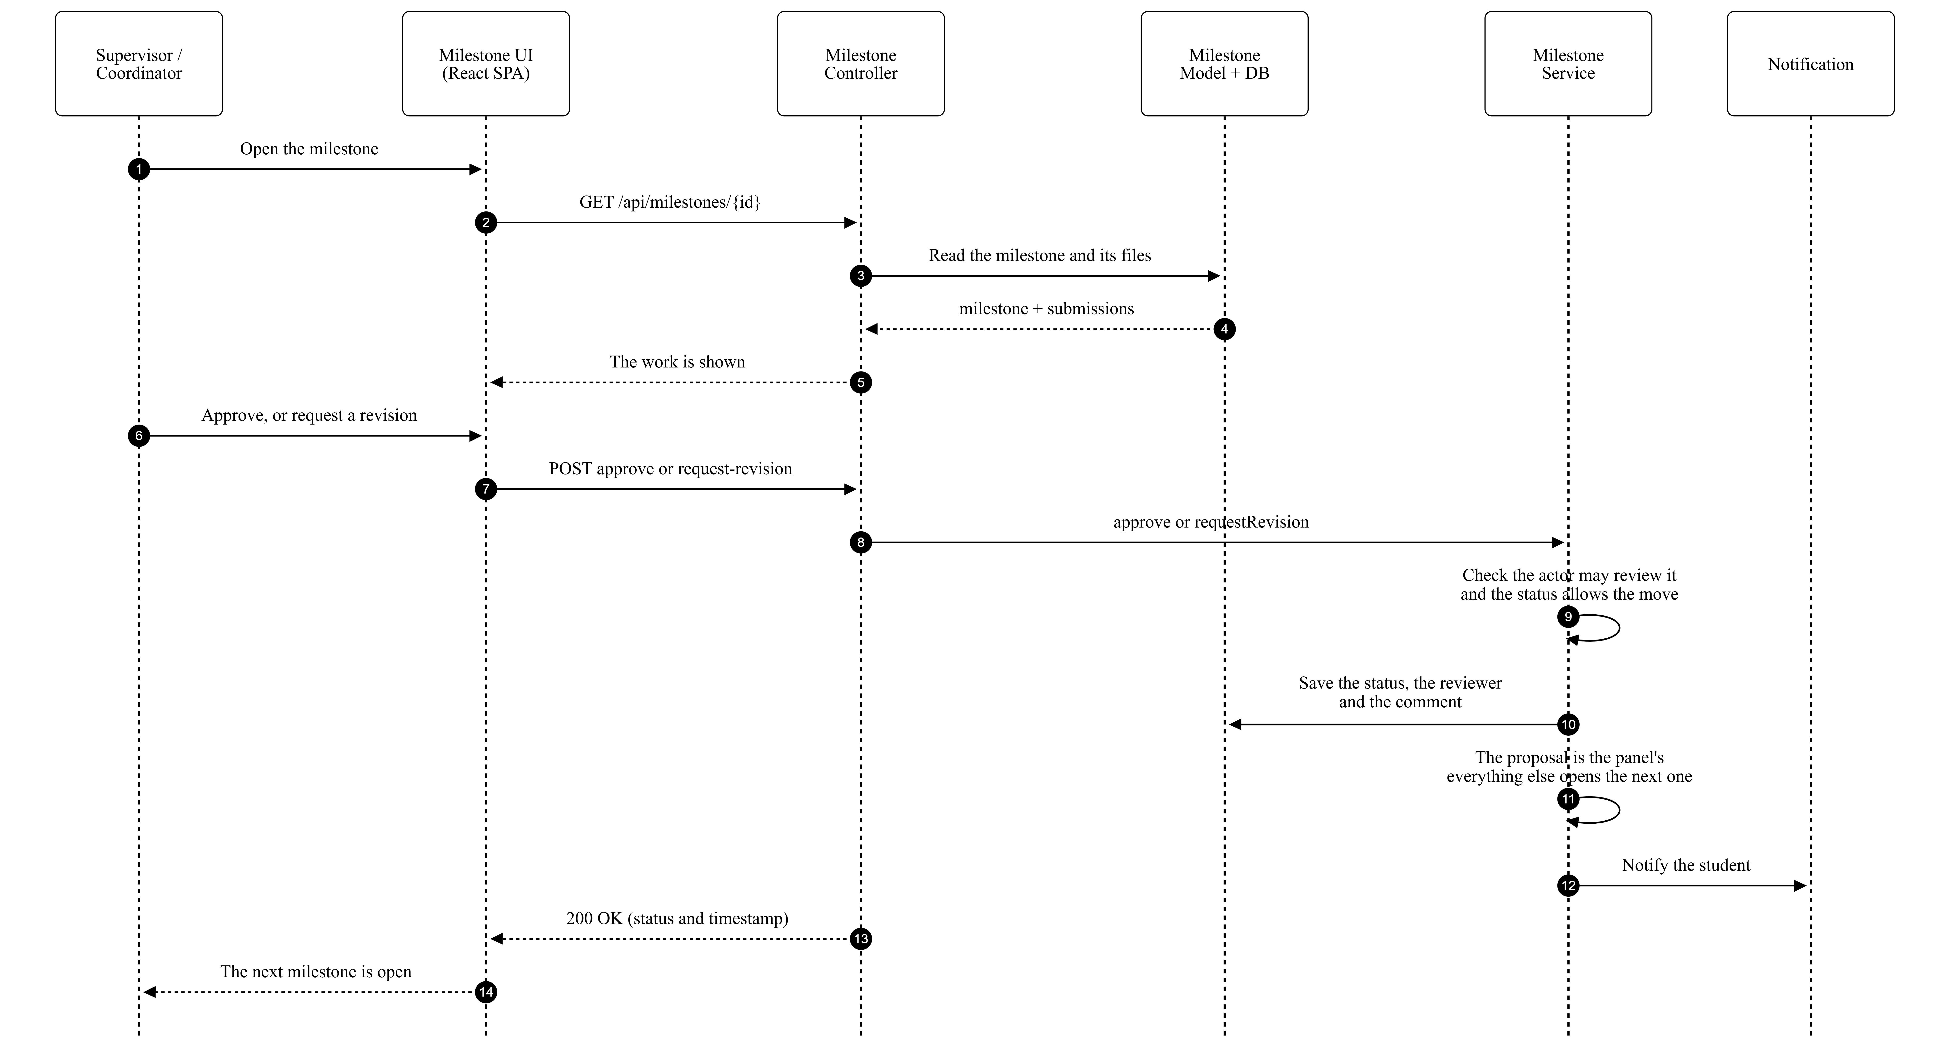
Figure 4.6: Sequence Diagram for Manage Milestone
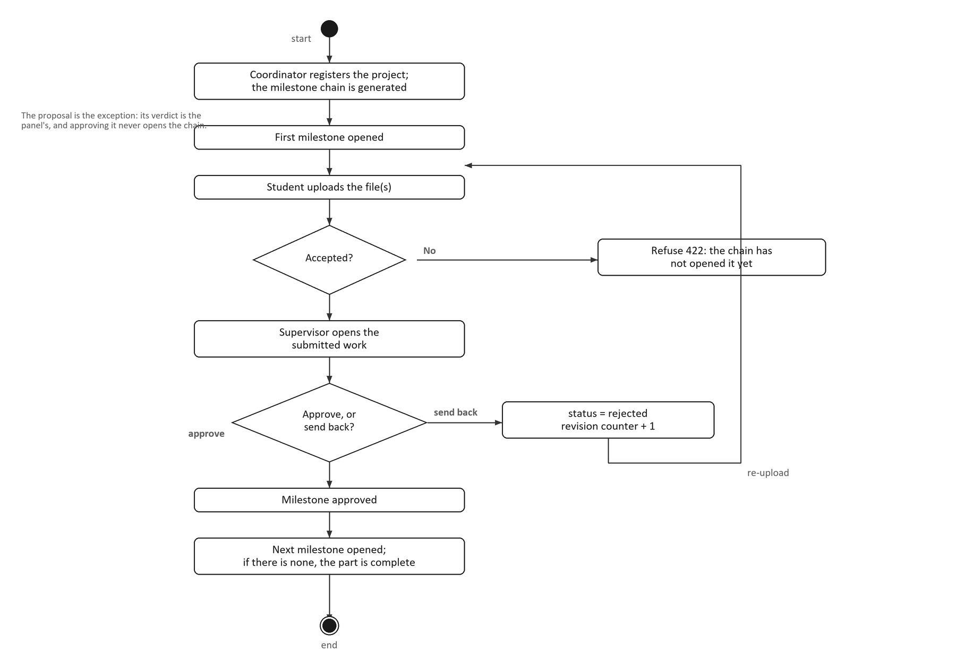
Figure 4.7: Activity Diagram for Manage Milestone
(iv) Use Case 4: Manage Evaluation
Table 4.7 specifies Manage Evaluation. It separates the two things an assessor does: saving a mark, which is editable and repeatable, and submitting the form, which is final and publishes the result.
Table 4.7: Manage Evaluation Use Case Specification
History Log | 1.0.0 Create initial use case.  2.0.0 Mark entry moves to the 0-5 scale, and the release step is removed.
Version | 2.0.0
Use Case ID | UC-04
Use Case Name | Manage Evaluation
Actors | Assessor, being the supervisor, an examiner or a lecturer (primary); Coordinator (allocates the forms).
Description | The assessor opens the form allocated to them and marks each criterion on a 0 to 5 scale. The system converts each item score to the rubric's own weight, so a Lampiran still totals what the form says while the marker answers on one scale. When every criterion is marked the assessor submits, which locks the form, recomputes the project's aggregate and makes the mark visible in the same step.
Preconditions | The coordinator has allocated the form to the assessor and has opened the assessment window for that form. The milestones the form depends on are approved.
Post conditions | The form is submitted and locked, the aggregate has been recomputed, and the student can see the mark. The item scores, the converted marks, the submitter and the time are all retained.
Normal Flow | 1. The assessor opens an allocated form.  2. The system loads the rubric and the existing scores.  3. The system shows one 0 to 5 select per criterion.  4. The assessor chooses a score for each criterion and may add a comment.  5. The system confirms that the form is editable and that its own window is open.  6. The system converts each item score to the criterion's weight and stores both.  7. The assessor submits the form.  8. The system confirms that every criterion is marked.  9. The system locks the form, recomputes the final mark and publishes it.  10. The system notifies the coordinator and the student.
Alternative Flow | A1. The form's own window is not open: the mark is refused. The window is per form, so opening Lampiran E does not open Lampiran I.  A2. The form is already submitted: it is locked and refuses the change.  A3. An item score is outside 0 to 5: it is refused and the assessor corrects it.  A4. A criterion is unmarked at submission: the submission is refused and each unmarked criterion is named.  A5. A dependent milestone is not approved: submission is refused.  A6. The assessor declares a conflict of interest: the form is marked recused and the coordinators are notified so a replacement can be allocated.
Exceptions | E.1 A student who did not attend is assessed as zero, which the assessor types. The system never assumes a zero: an incomplete form is refused, and an assessed zero is complete.

Figure 4.8: Sequence Diagram for Manage Evaluation
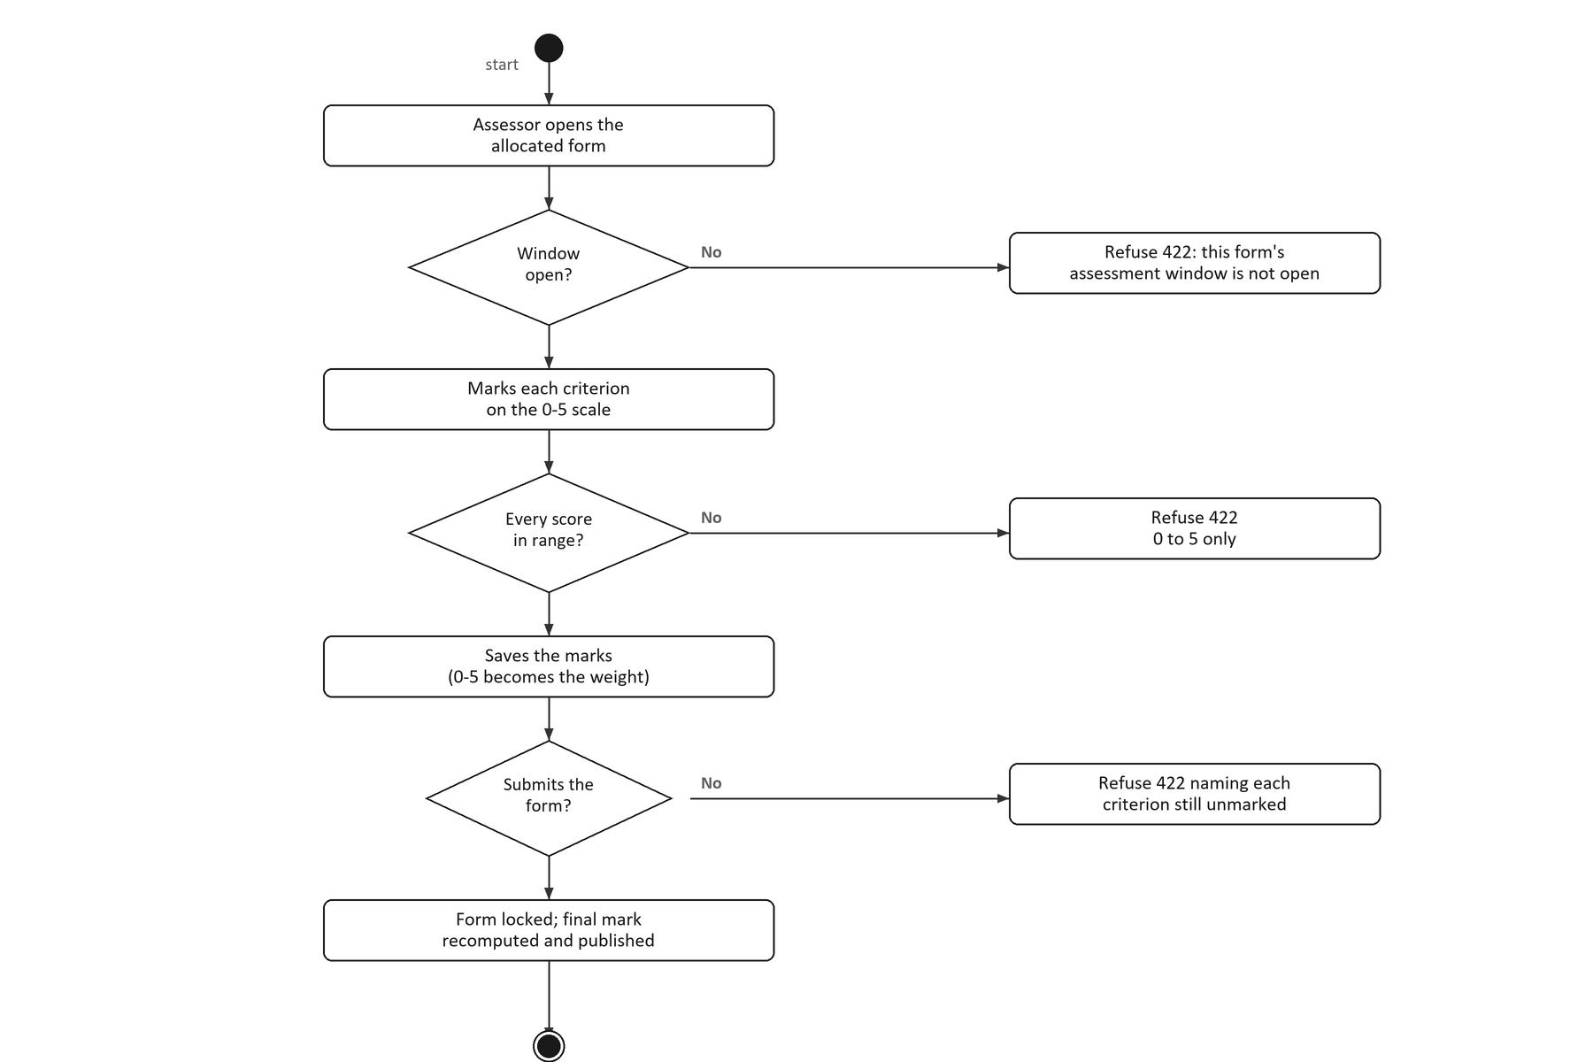
Figure 4.9: Activity Diagram for Manage Evaluation
(v) Use Case 5: Generate Report
Table 4.8 specifies Generate Report. Every report is built from the same three filters — the batch, the PSM part and the academic semester — and produces either figures for the screen or a CSV file.
Table 4.8: Generate Report Use Case Specification
History Log | 1.0.0 Create initial use case.  2.0.0 Add the CSV export and its audit entry.
Version | 2.0.0
Use Case ID | UC-05
Use Case Name | Generate Report
Actors | Coordinator (primary), Admin.
Description | The coordinator selects a batch, a PSM part and a semester, and the system produces cohort analytics: progress, students at risk, supervisor and examiner workload, mark distribution and milestone breakdown. The coordinator may also export the grade or project list as a CSV file.
Preconditions | The coordinator is signed in and holds the analytics permission. Projects and assessments exist for the chosen filters.
Post conditions | The coordinator sees the figures for the chosen filters, or receives a CSV file. The export is recorded in the audit log. No underlying data is modified.
Normal Flow | 1. The coordinator opens the report screen.  2. The coordinator chooses the batch, the PSM part and the semester.  3. The system confirms that the caller may view cohort analytics.  4. The system aggregates progress, the students at risk, workload and the mark bands.  5. The system returns the figures and the interface renders them.  6. For an export, the system applies the narrower export permission.  7. The system records the export and streams the rows.  8. The coordinator saves the file.
Alternative Flow | A1. The caller may not view analytics: the system returns 403 Forbidden.  A2. A filter names a semester that does not exist: the filters are rejected.  A3. Export is chosen: the export permission is narrower than the analytics permission, and is limited to coordinators and administrators.  A4. No grade has been released: the mark distribution returns empty bands rather than zero, because no mark is not a mark of zero.
Exceptions | E.1 A grade without a final mark is exported with a blank verdict rather than as a fail, and is excluded from the displayed pass rate.

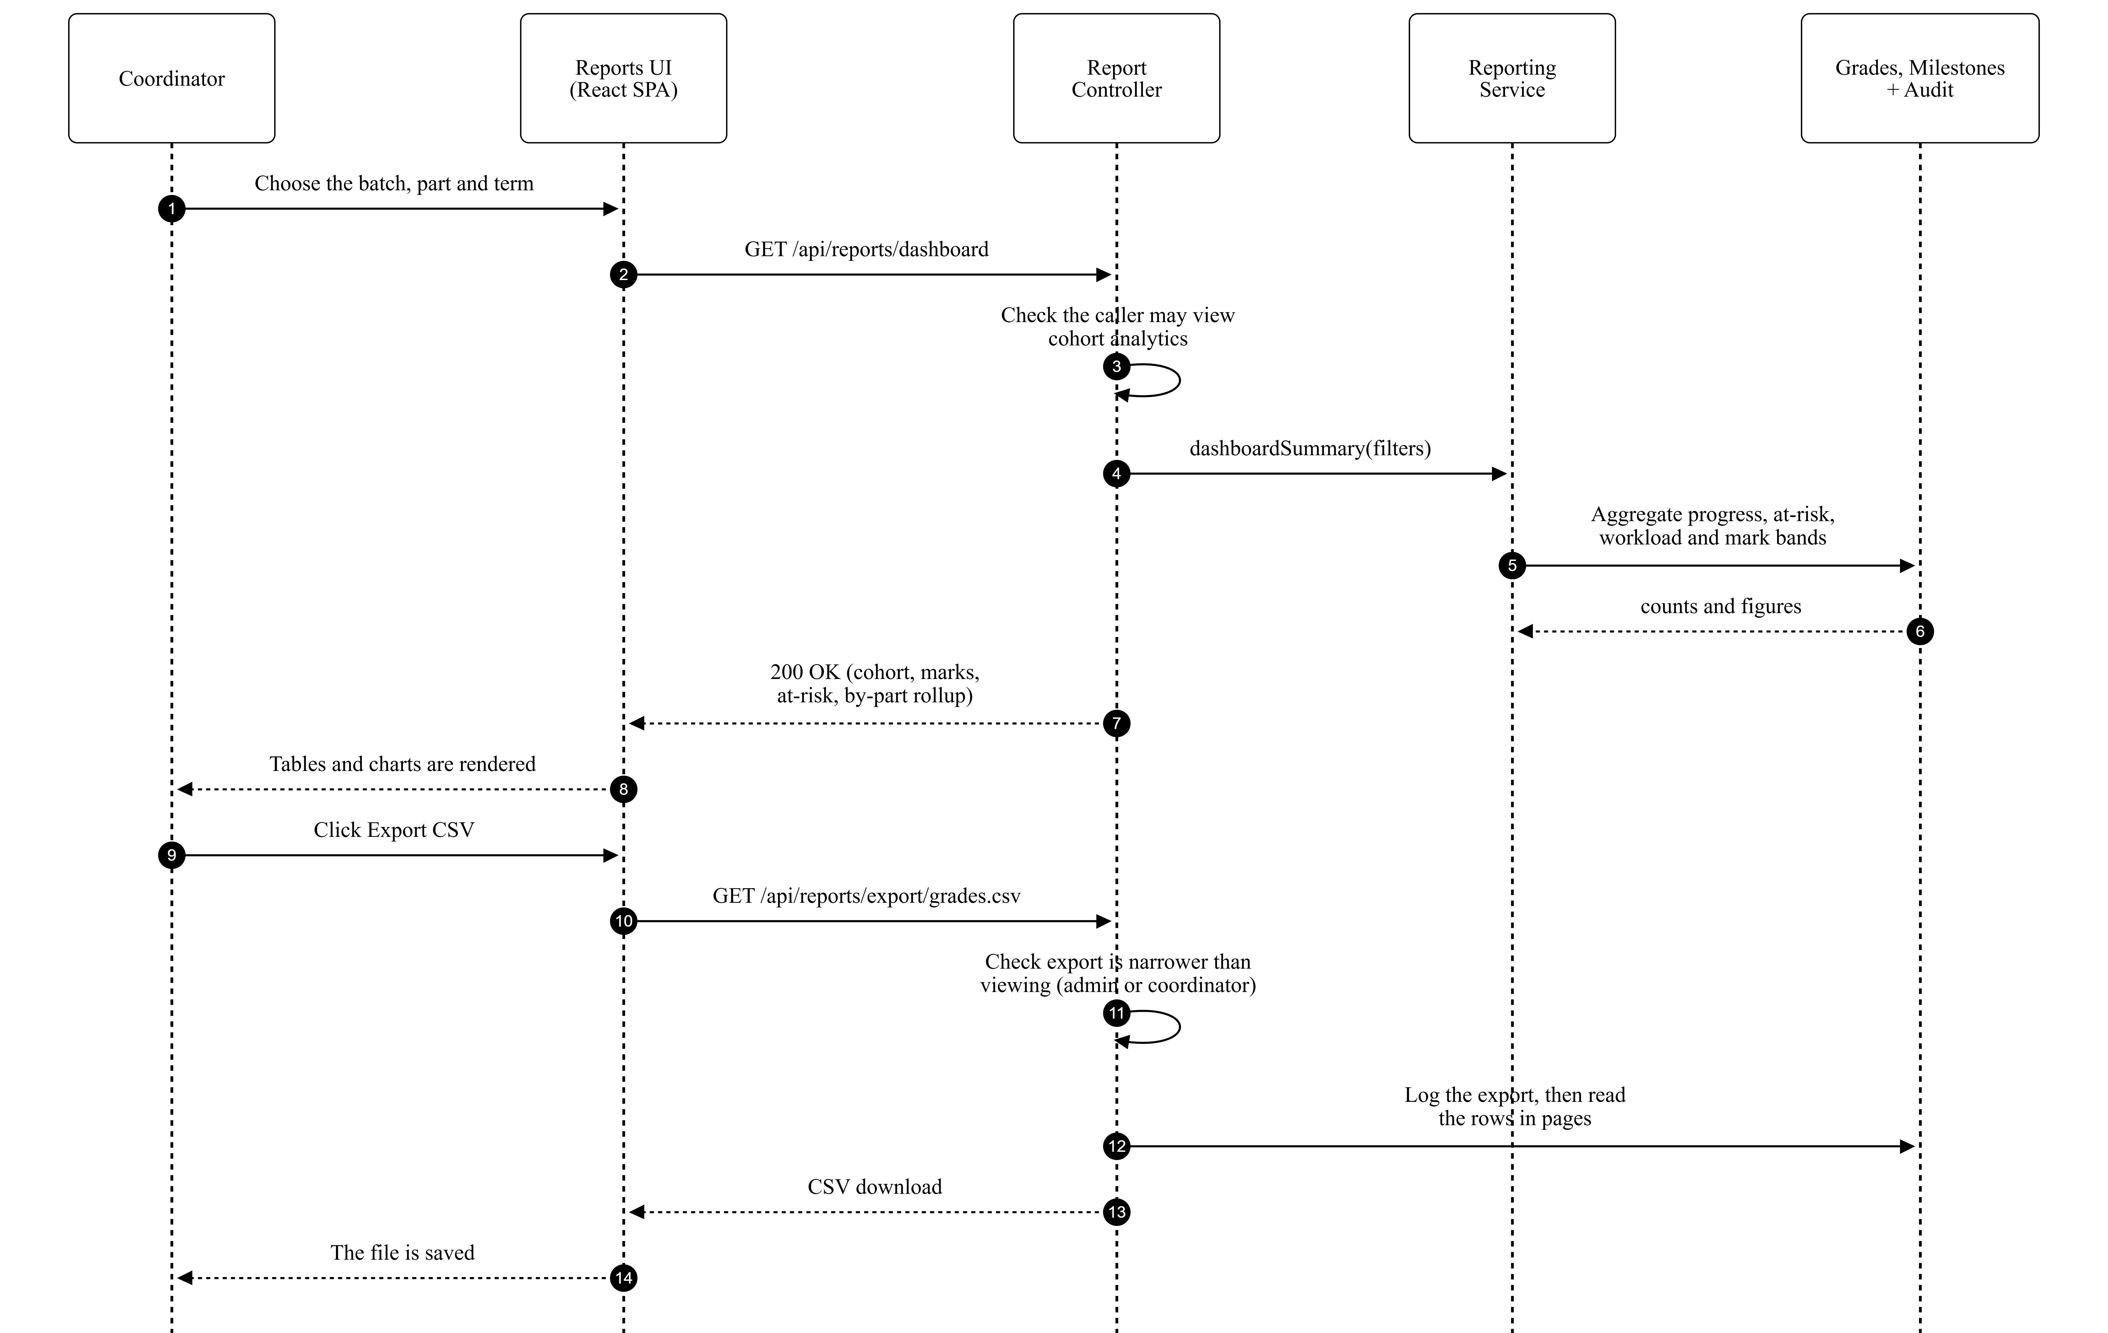
Figure 4.10: Sequence Diagram for Generate Report
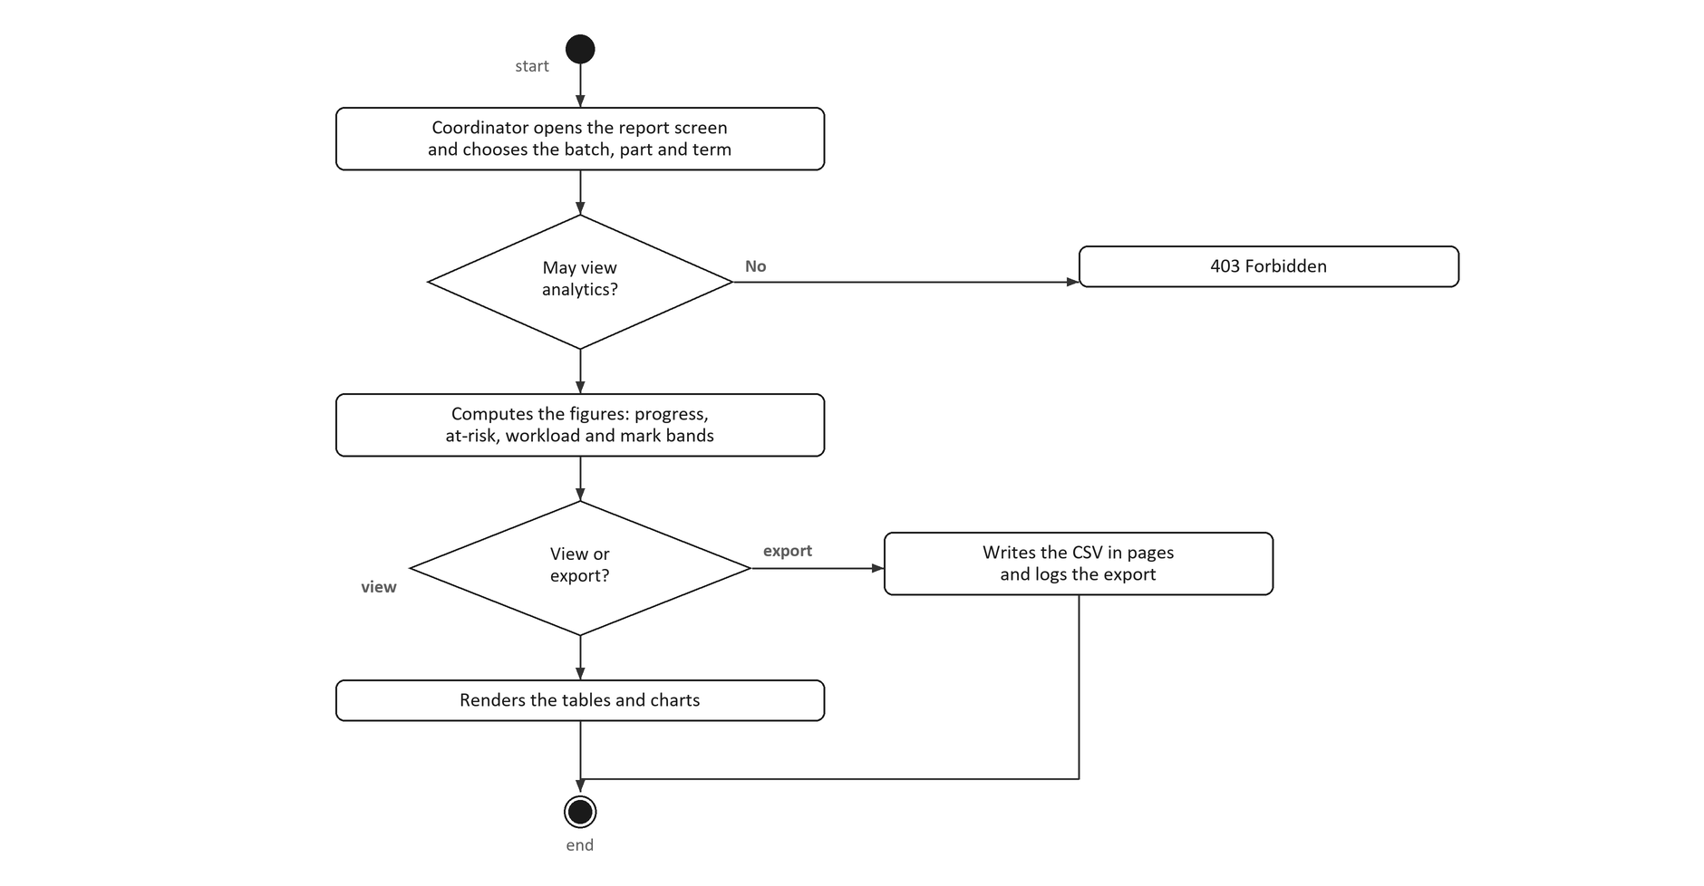
Figure 4.11: Activity Diagram for Generate Report
(vi) Use Case 6: Manage Alert and Notification
Table 4.9 specifies Manage Alert and Notification. It has two halves that never call each other: the scheduled reminder, which the system drives, and the notification centre, which the user drives.
Table 4.9: Manage Alert and Notification Use Case Specification
History Log | 1.0.0 Create initial use case.  2.0.0 Add the de-duplication ledger and the preference rules.
Version | 2.0.0
Use Case ID | UC-06
Use Case Name | Manage Alert and Notification
Actors | System scheduler (primary, for the reminders); every signed-in user (for the notification centre).
Description | The system sends deadline reminders seven, three and one days before a milestone is due, and records each one so a retried run cannot send it twice. Every user has a notification centre where they read and dismiss items and choose which types they receive.
Preconditions | Milestones with deadlines exist for the reminder run. The user is signed in for the centre.
Post conditions | A reminder has been sent once per recipient per wave, and is recorded in the ledger. Changes to preferences are saved.
Normal Flow | 1. The scheduled command runs.  2. The system finds the milestones due in seven, three or one days.  3. The system checks that each user is active, has not opted out, and has not already been sent this wave.  4. The system writes the in-app record and sends the mail.  5. The system records the dispatch in the ledger.  6. The system moves to the next wave or finishes.  7. The user opens the notification centre and reads or dismisses an item.  8. The user may change which notification types they receive.
Alternative Flow | A1. Nothing is due in a wave: the run moves to the next wave.  A2. The wave has already been sent to this recipient: it is skipped, which is what keeps a retried run safe.  A3. The user has opted out of that type, or is inactive: nothing is sent.  A4. The user turns off a type the faculty treats as mandatory: the change is ignored, so those notifications always arrive.
Exceptions | E.1 A mail transport failure leaves the ledger entry unwritten, so the next run retries the same recipient rather than losing the reminder.

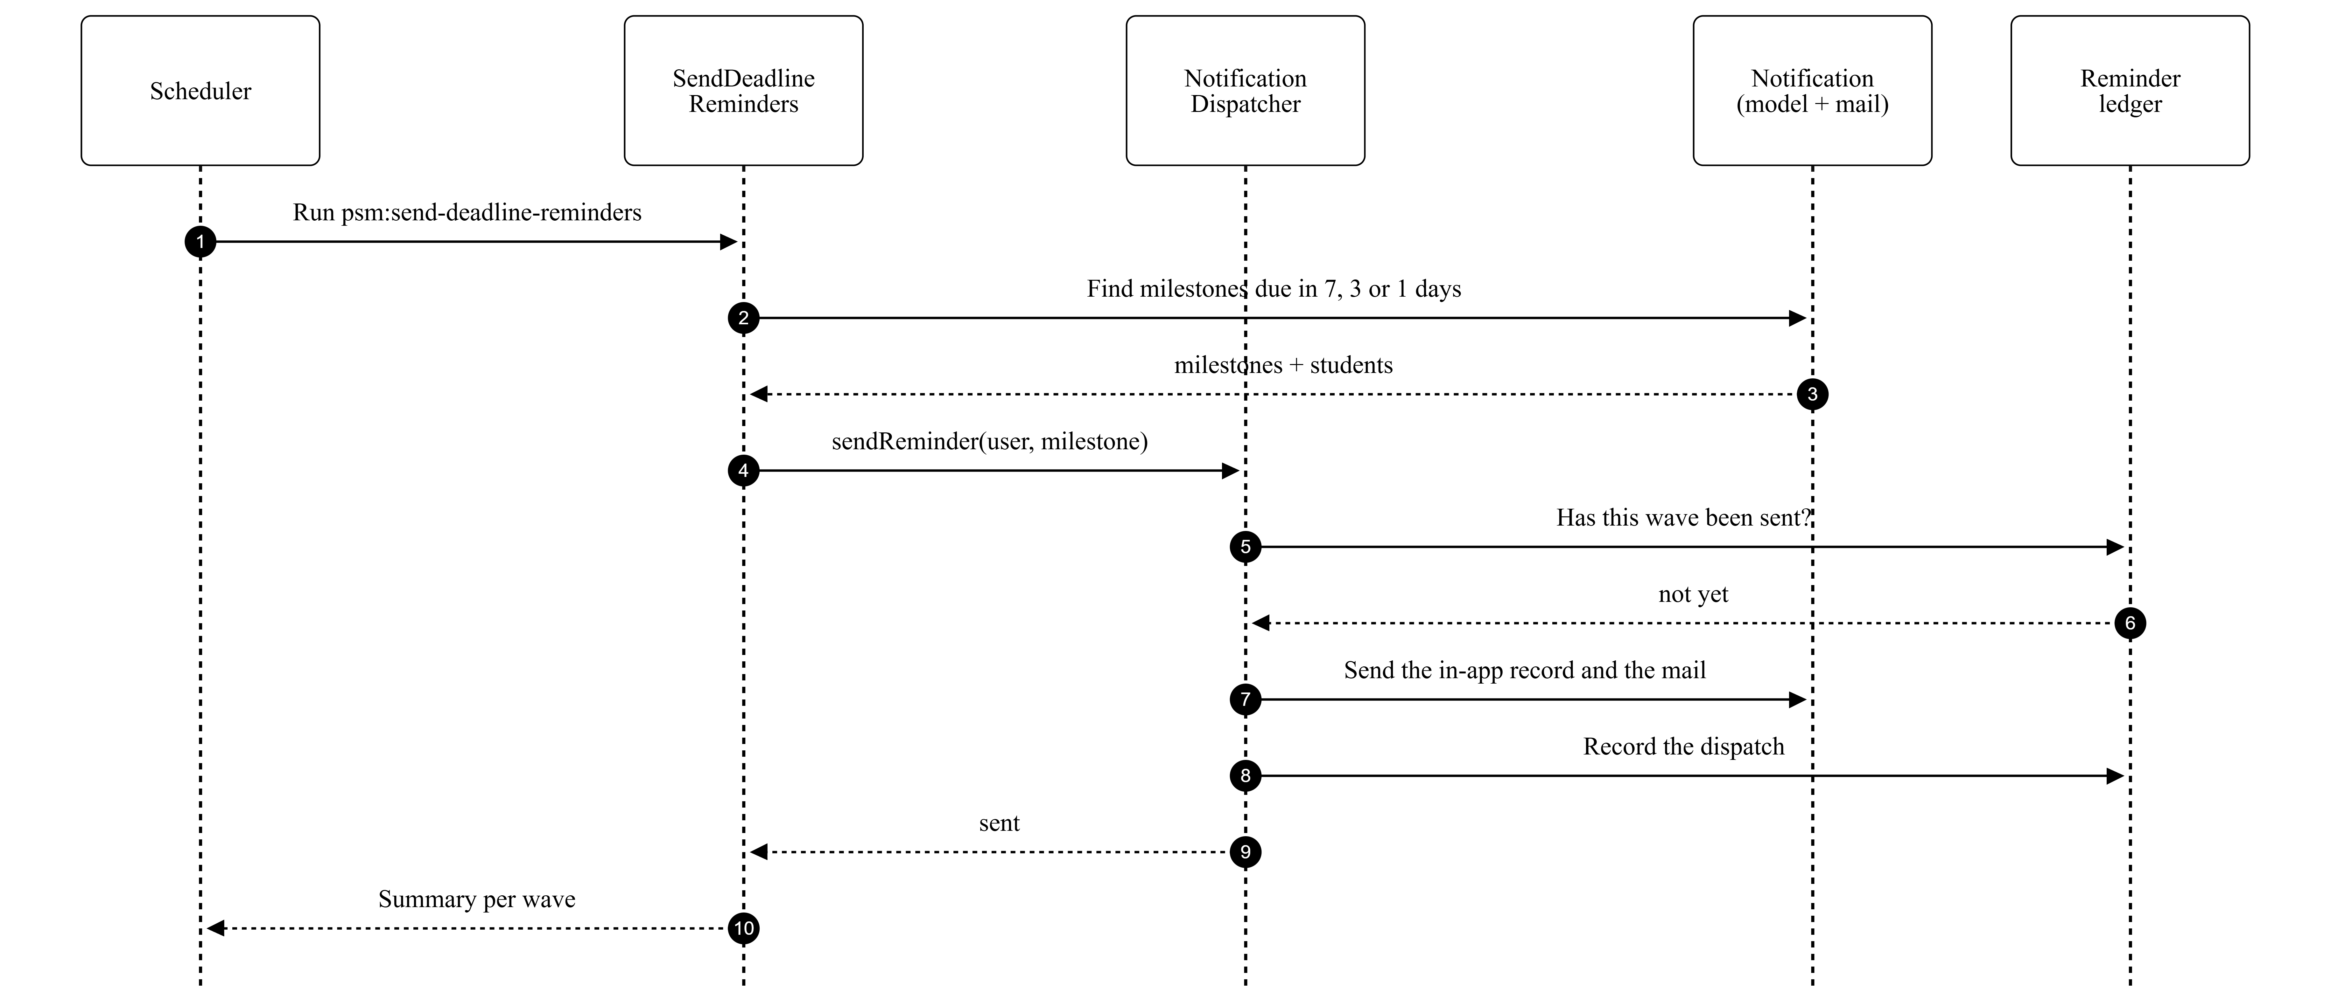
Figure 4.12: Sequence Diagram for Manage Alert and Notification
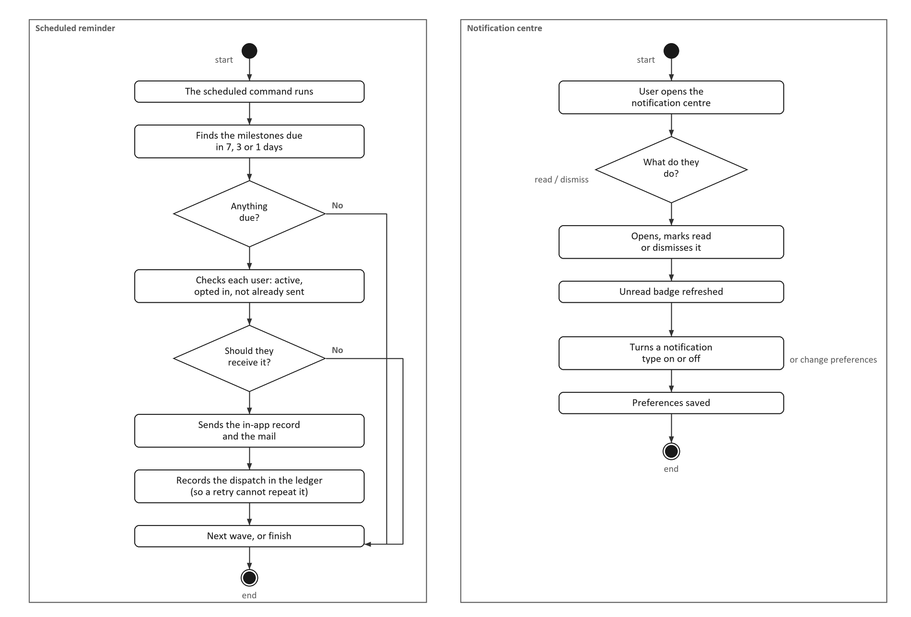
Figure 4.13: Activity Diagram for Manage Alert and Notification

4.3 Design
Once the requirements were analysed, the project moved to design. This section covers the system architecture, the database design, the interface design and the class model, so that the structure of the system can be reviewed before it is described in implementation.

4.3.1 System Architecture
The system is a three-tier web application. The browser runs a single-page application written in React; the server is a Laravel API that holds every rule; and the data lives in PostgreSQL, with uploaded evidence in object storage. The client holds no business rule — every permission, every guard and every calculation is enforced on the server, so a compromised browser cannot grant itself a mark.

4.3.2 Database Design
The database has eighteen tables. The schema is summarised below with the primary and foreign keys, and the eight core tables are then described in full. A data dictionary for the remaining ten would repeat the same three columns — an identifier, a foreign key and a timestamp — without adding to the design.
Schema summary:
1. users (PK id)
2. student_profiles (PK id, FK user_id)
3. supervisor_profiles (PK id, FK user_id)
4. academic_semesters (PK id)
5. supervisor_agreements (PK id, FK student_profile_id, FK supervisor_profile_id)
6. projects (PK id, FK agreement_id, FK academic_semester_id)
7. lampiran_b_forms (PK id, FK project_id)
8. milestones (PK id, FK project_id)
9. submission_files (PK id, FK milestone_id)
10. supervision_assignments (PK id, FK student_profile_id, FK supervisor_profile_id)
11. examiner_assignments (PK id, FK project_id, FK examiner_id)
12. evaluations (PK id, FK project_id, FK assessor_id)
13. evaluation_scores (PK id, FK evaluation_id)
14. mark_submissions (PK id, FK project_id, FK student_profile_id)
15. final_grades (PK id, FK project_id)
16. student_enrolments (PK id, FK student_profile_id, FK academic_semester_id)
17. sections (PK id, FK academic_semester_id)
18. lecturer_marks (PK id, FK section_id)
19. notifications (PK id, FK user_id)
20. audit_logs (PK id, FK actor_id)
Table 4.10: Data Dictionary — core tables
User table
The User table, shown in Table 4.11: Stores every account: students, supervisors, lecturers, coordinators and administrators. The role column decides what a session may reach, and the lockout columns implement the authentication rule.
Table 4.11: User table
Attributes | Data Type | Size | Key | Descriptions
id | BIGINT | 11 | Primary | Unique identifier
name | VARCHAR | 255 | None | Full name
email | VARCHAR | 255 | None | Sign-in address; unique
email_verified_at | TIMESTAMP | - | None | When email verified happened
password | VARCHAR | 255 | None | Password hash, never the password
role | VARCHAR | 255 | None | student, supervisor, lecturer, coordinator or admin
status | VARCHAR | 255 | None | Lifecycle state of the row
phone | VARCHAR | 32 | None | Phone
avatar_path | VARCHAR | 255 | None | Avatar path
staff_id | VARCHAR | 64 | None | Staff id
department | VARCHAR | 255 | None | Department
must_change_password | BOOLEAN | - | None | Must change password
last_login_at | TIMESTAMP | - | None | When last login happened
last_login_ip | VARCHAR | 45 | None | Last login ip
failed_login_attempts | SMALLINT | 11 | None | Consecutive failures; drives the lockout
locked_until | TIMESTAMP | - | None | Sign-in is refused until this moment
notification_preferences | JSON | - | None | Notification preferences
digest_only | BOOLEAN | - | None | Digest only
remember_token | VARCHAR | 100 | None | Remember token
created_at | TIMESTAMP | - | None | When created happened
updated_at | TIMESTAMP | - | None | When updated happened
deleted_at | TIMESTAMP | - | None | When deleted happened
Project table
The Project table, shown in Table 4.12: One row per registered project. It carries the agreed title, the PSM part and the status, and it is the row every other record hangs from.
Table 4.12: Project table
Attributes | Data Type | Size | Key | Descriptions
id | BIGINT | 11 | Primary | Unique identifier
code | VARCHAR | 32 | None | Short display code, unique within its scope
title | VARCHAR | 255 | None | The title as agreed or proposed
abstract | TEXT | - | None | Abstract
objectives | TEXT | - | None | Objectives
scope | TEXT | - | None | Scope
category | VARCHAR | 255 | None | Category
psm_part | VARCHAR | 255 | None | PSM1 or PSM2
academic_session | VARCHAR | 32 | None | Academic session
batch | VARCHAR | 32 | None | Batch
program | VARCHAR | 128 | None | Program
status | VARCHAR | 255 | None | Lifecycle state of the row
created_by | BIGINT | 11 | Foreign | The user who created the row
approved_by | BIGINT | 11 | Foreign | The user who approved it
submitted_at | TIMESTAMP | - | None | When the work was handed in
approved_at | TIMESTAMP | - | None | When it was approved
rejection_reason | TEXT | - | None | Rejection reason
archived_at | TIMESTAMP | - | None | When archived happened
leaderboard_opt_out | BOOLEAN | - | None | Leaderboard opt out
metadata | JSON | - | None | Metadata
created_at | TIMESTAMP | - | None | When created happened
updated_at | TIMESTAMP | - | None | When updated happened
deleted_at | TIMESTAMP | - | None | When deleted happened
agreement_id | BIGINT | 11 | Foreign | Links to the Lampiran A agreement it was registered from
academic_semester_id | BIGINT | 11 | Foreign | Links to the term
Milestone table
The Milestone table, shown in Table 4.13: One row per milestone of a project's chain. The attempt column lets a milestone code repeat when a title has to be re-presented.
Table 4.13: Milestone table
Attributes | Data Type | Size | Key | Descriptions
id | BIGINT | 11 | Primary | Unique identifier
project_id | BIGINT | 11 | Foreign | Links to the project
milestone_template_item_id | BIGINT | 11 | Foreign | Links to milestone_template_items
code | VARCHAR | 32 | None | Short display code, unique within its scope
title | VARCHAR | 255 | None | The title as agreed or proposed
description | TEXT | - | None | Description
sequence | SMALLINT | 11 | None | Sequence
weight_percent | NUMERIC | - | None | Weight percent
status | VARCHAR | 255 | None | Lifecycle state of the row
opens_at | DATE | - | None | When the chain opened this milestone
due_at | DATE | - | None | Deadline; shared by every student
allow_late_submission | BOOLEAN | - | None | Allow late submission
late_window_days | SMALLINT | 11 | None | Late window days
extended_until | TIMESTAMP | - | None | Extended until
reviewed_by | BIGINT | 11 | Foreign | Links to users
submitted_at | TIMESTAMP | - | None | When the work was handed in
reviewed_at | TIMESTAMP | - | None | When reviewed happened
approved_at | TIMESTAMP | - | None | When it was approved
review_comment | TEXT | - | None | Review comment
revision_count | SMALLINT | 11 | None | Revision count
deadline_overridden_by | BIGINT | 11 | Foreign | Links to users
deadline_override_reason | TEXT | - | None | Deadline override reason
allowed_file_types | JSON | - | None | Allowed file types
max_files | SMALLINT | 11 | None | Max files
requires_supervisor_approval | BOOLEAN | - | None | Requires supervisor approval
created_at | TIMESTAMP | - | None | When created happened
updated_at | TIMESTAMP | - | None | When updated happened
deleted_at | TIMESTAMP | - | None | When deleted happened
lampiran_c_title | VARCHAR | 255 | None | Lampiran c title
lampiran_c_actions | JSON | - | None | Lampiran c actions
lampiran_c_at | TIMESTAMP | - | None | When lampiran c happened
lampiran_c_by | BIGINT | 11 | Foreign | Links to users
deadline_is_fixed | BOOLEAN | - | None | Deadline is fixed
requires_lampiran_c | TEXT | - | None | Requires lampiran c
lampiran_c_previous_title | VARCHAR | 255 | None | Lampiran c previous title
lampiran_c_new_title | VARCHAR | 255 | None | Lampiran c new title
lampiran_c_filed_at | TIMESTAMP | - | None | When lampiran c filed happened
lampiran_c_filed_by | BIGINT | 11 | Foreign | Links to users
supervisor_signature_path | VARCHAR | 255 | None | Supervisor signature path
supervisor_signature_disk | VARCHAR | 32 | None | Supervisor signature disk
supervisor_signature_type | VARCHAR | 16 | None | Supervisor signature type
supervisor_signed_at | TIMESTAMP | - | None | When supervisor signed happened
supervisor_signed_by | BIGINT | 11 | Foreign | Links to users
lampiran_c_ic_number | VARCHAR | 32 | None | Lampiran c ic number
lampiran_c_passport_number | VARCHAR | 32 | None | Lampiran c passport number
lampiran_c_mobile_number | VARCHAR | 32 | None | Lampiran c mobile number
lampiran_c_defense_date | DATE | - | None | Lampiran c defense date
student_signature_path | VARCHAR | 255 | None | Student signature path
student_signature_disk | VARCHAR | 32 | None | Student signature disk
student_signature_type | VARCHAR | 16 | None | Student signature type
student_signed_at | TIMESTAMP | - | None | When student signed happened
attempt | SMALLINT | 11 | None | Which re-presentation of this milestone this is
Evaluation table
The Evaluation table, shown in Table 4.14: One row per assessor per project: the form the assessor holds, its rubric snapshot and its status.
Table 4.14: Evaluation table
Attributes | Data Type | Size | Key | Descriptions
id | BIGINT | 11 | Primary | Unique identifier
project_id | BIGINT | 11 | Foreign | Links to the project
assessor_id | BIGINT | 11 | Foreign | Links to users
rubric_template_id | BIGINT | 11 | Foreign | Links to rubric_templates
rubric_snapshot | JSON | - | None | Rubric snapshot
assessor_type | VARCHAR | 255 | None | Assessor type
psm_part | VARCHAR | 255 | None | PSM1 or PSM2
status | VARCHAR | 255 | None | Lifecycle state of the row
raw_score | NUMERIC | - | None | Raw score
max_score | NUMERIC | - | None | Max score
score_percent | NUMERIC | - | None | The form's own percentage
final_score | NUMERIC | - | None | Final score
moderation_delta | NUMERIC | - | None | Moderation delta
comment | TEXT | - | None | Comment
strengths | TEXT | - | None | Strengths
improvements | TEXT | - | None | Improvements
is_late_assessment | BOOLEAN | - | None | Is late assessment
submitted_at | TIMESTAMP | - | None | When the work was handed in
released_at | TIMESTAMP | - | None | When the mark became visible to the student
moderated_by | BIGINT | 11 | Foreign | Links to users
moderation_reason | TEXT | - | None | Moderation reason
moderated_at | TIMESTAMP | - | None | When moderated happened
coi_declaration | TEXT | - | None | Coi declaration
created_at | TIMESTAMP | - | None | When created happened
updated_at | TIMESTAMP | - | None | When updated happened
form_instance | VARCHAR | 16 | None | Form instance
EvaluationScore table
The EvaluationScore table, shown in Table 4.15: One row per criterion of one evaluation. The marks column holds the weighted mark and item_score holds the 0-5 answer, so the two can always be reconciled.
Table 4.15: EvaluationScore table
Attributes | Data Type | Size | Key | Descriptions
id | BIGINT | 11 | Primary | Unique identifier
evaluation_id | BIGINT | 11 | Foreign | Links to the evaluation this score belongs to
rubric_component_id | BIGINT | 11 | Foreign | Links to rubric_components
rubric_criterion_id | BIGINT | 11 | Foreign | Links to rubric_criteria
component_code | VARCHAR | 32 | None | Component code
criterion_code | VARCHAR | 32 | None | Which rubric criterion this score is for
criterion_title | VARCHAR | 255 | None | Criterion title
max_marks | NUMERIC | - | None | Max marks
marks_awarded | NUMERIC | - | None | Marks awarded
weighted_contribution | NUMERIC | - | None | Weighted contribution
comment | TEXT | - | None | Comment
is_flagged | BOOLEAN | - | None | Is flagged
created_at | TIMESTAMP | - | None | When created happened
updated_at | TIMESTAMP | - | None | When updated happened
item_score | NUMERIC | - | None | Item score
MarkSubmission table
The MarkSubmission table, shown in Table 4.16: One row per project, student and part: the unit that says whether every assessor has filed, and whether the mark is locked.
Table 4.16: MarkSubmission table
Attributes | Data Type | Size | Key | Descriptions
id | BIGINT | 11 | Primary | Unique identifier
project_id | BIGINT | 11 | Foreign | Links to the project
student_profile_id | BIGINT | 11 | Foreign | Links to the student
psm_part | VARCHAR | 255 | None | PSM1 or PSM2
academic_semester_id | BIGINT | 11 | Foreign | Links to the term
status | VARCHAR | 255 | None | Lifecycle state of the row
expected_panel_size | SMALLINT | 11 | None | Expected panel size
opened_by | BIGINT | 11 | Foreign | Links to users
opened_at | TIMESTAMP | - | None | When opened happened
locked_by | BIGINT | 11 | Foreign | Links to users
locked_at | TIMESTAMP | - | None | When the mark was locked
unlock_reason | TEXT | - | None | Unlock reason
final_grade_id | BIGINT | 11 | Foreign | Links to final_grades
notes | TEXT | - | None | Notes
created_at | TIMESTAMP | - | None | When created happened
updated_at | TIMESTAMP | - | None | When updated happened
FinalGrade table
The FinalGrade table, shown in Table 4.17: One row per project. The aggregate of every assessor's form, and the number the pass mark is applied to.
Table 4.17: FinalGrade table
Attributes | Data Type | Size | Key | Descriptions
id | BIGINT | 11 | Primary | Unique identifier
project_id | BIGINT | 11 | Foreign | Links to the project
student_profile_id | BIGINT | 11 | Foreign | Links to the student
psm_part | VARCHAR | 255 | None | PSM1 or PSM2
supervisor_score | NUMERIC | - | None | Supervisor score
examiner_score | NUMERIC | - | None | Examiner score
coordinator_score | NUMERIC | - | None | Coordinator score
aggregate_percent | NUMERIC | - | None | Aggregate percent
milestone_score | NUMERIC | - | None | Milestone score
final_mark | NUMERIC | - | None | The aggregate the pass mark is applied to
assessor_count | SMALLINT | 11 | None | Assessor count
computation_breakdown | JSON | - | None | Computation breakdown
status | VARCHAR | 255 | None | Lifecycle state of the row
computed_at | TIMESTAMP | - | None | When computed happened
released_at | TIMESTAMP | - | None | When the mark became visible to the student
released_by | BIGINT | 11 | Foreign | Links to users
is_publishable | BOOLEAN | - | None | Is publishable
created_at | TIMESTAMP | - | None | When created happened
updated_at | TIMESTAMP | - | None | When updated happened
locked_at | TIMESTAMP | - | None | When the mark was locked
locked_by | BIGINT | 11 | Foreign | Links to users
examiner_panel_average | NUMERIC | - | None | Examiner panel average
StudentEnrolment table
The StudentEnrolment table, shown in Table 4.18: One row per student, part and semester, with the attempt number. This is where a student's term lives.
Table 4.18: StudentEnrolment table
Attributes | Data Type | Size | Key | Descriptions
id | BIGINT | 11 | Primary | Unique identifier
student_profile_id | BIGINT | 11 | Foreign | Links to the student
academic_semester_id | BIGINT | 11 | Foreign | Links to the term
psm_part | VARCHAR | 8 | None | PSM1 or PSM2
attempt_no | SMALLINT | 11 | None | Which attempt at the part this enrolment is
status | VARCHAR | 16 | None | Lifecycle state of the row
project_id | BIGINT | 11 | Foreign | Links to the project
repeats_enrolment_id | BIGINT | 11 | Foreign | Links to student_enrolments
enrolled_at | TIMESTAMP | - | None | When enrolled happened
settled_at | TIMESTAMP | - | None | When settled happened
note | TEXT | - | None | Note
enrolled_by | BIGINT | 11 | Foreign | Links to users
created_at | TIMESTAMP | - | None | When created happened
updated_at | TIMESTAMP | - | None | When updated happened

4.3.3 Interface Design
The following screens carry the six use cases. They are built with the React single-page application shell, so a user moves between them without a page load, and each screen shows only the actions the signed-in role may take.
The login screen accepts an email address and a password and, on failure, shows one message for every cause, so it cannot be used to discover which addresses exist. The registration screen collects Lampiran A, with the session as a list of the open terms rather than a free-text field. The milestone screen shows the chain, the work submitted to the open milestone and the reviewer's decision. The evaluation screen shows one 0-5 select per rubric criterion with the form's window and status. The report screen shows the cohort figures with the three filters, and the export button beside them.
Each screen is captured from the running system for Chapter 5, where the implementation is described. They are not reproduced here: this chapter is the design, and the design of a screen is its fields and the rule each field obeys, which the use-case specifications above already record.
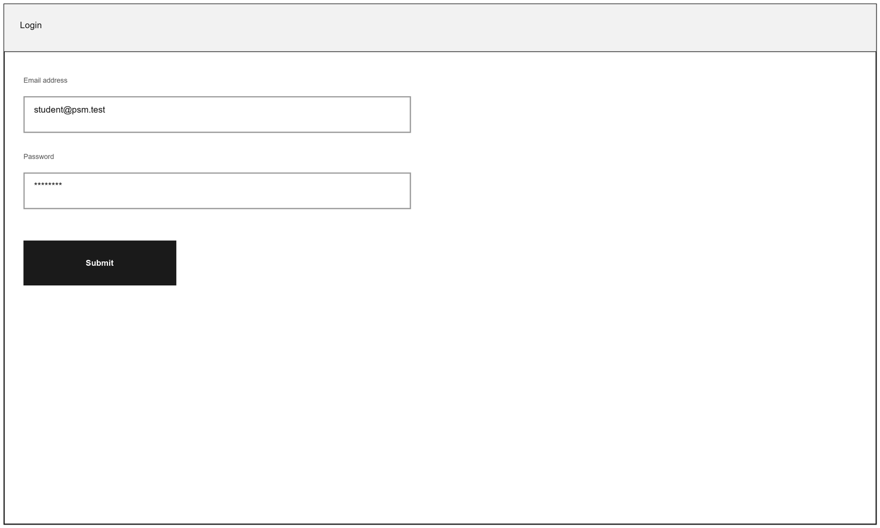
Figure 4.15: Login
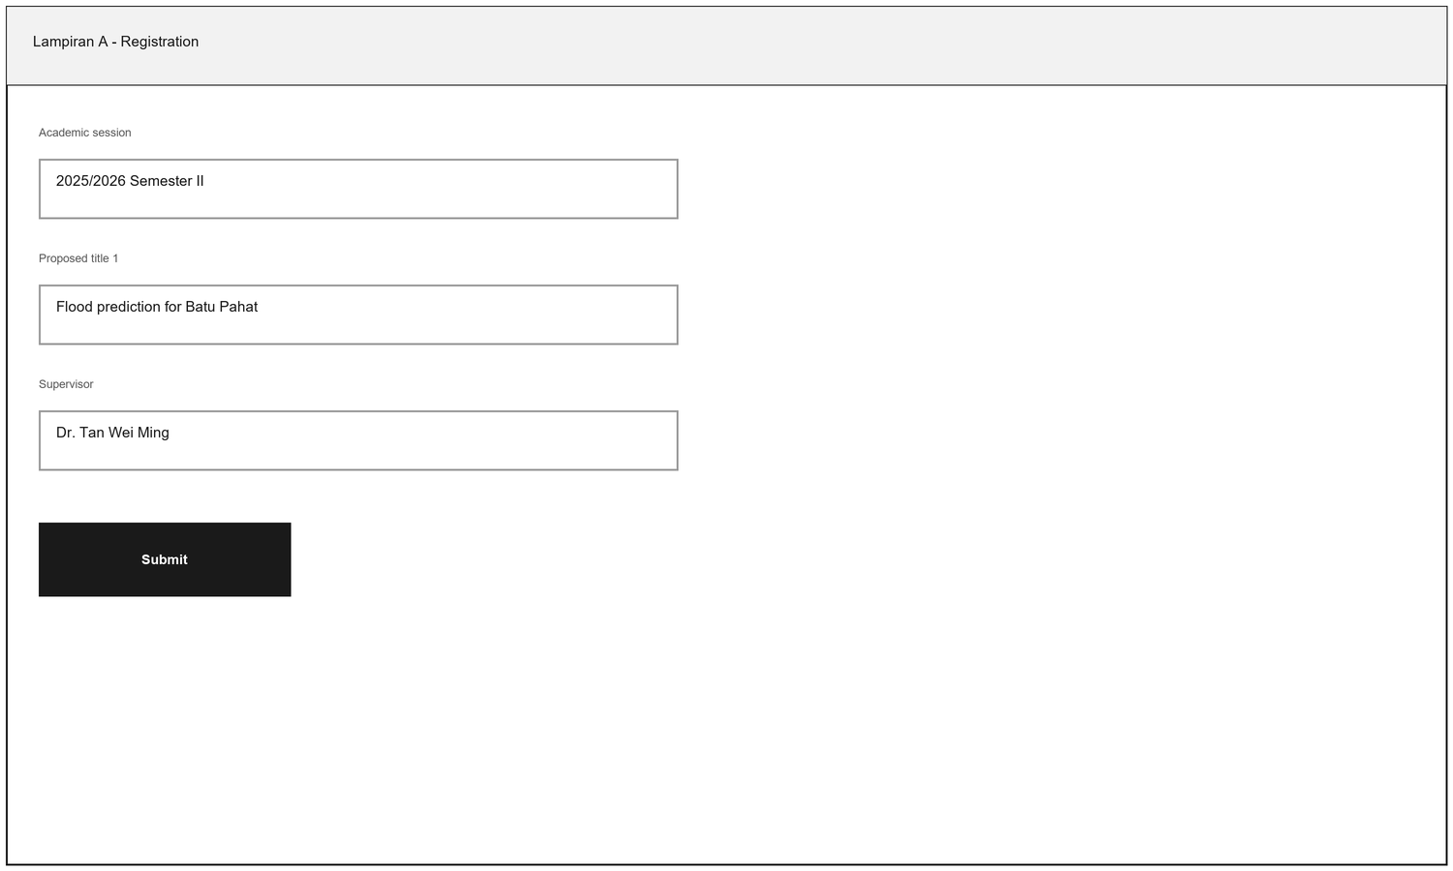
Figure 4.16: Lampiran A - Registration
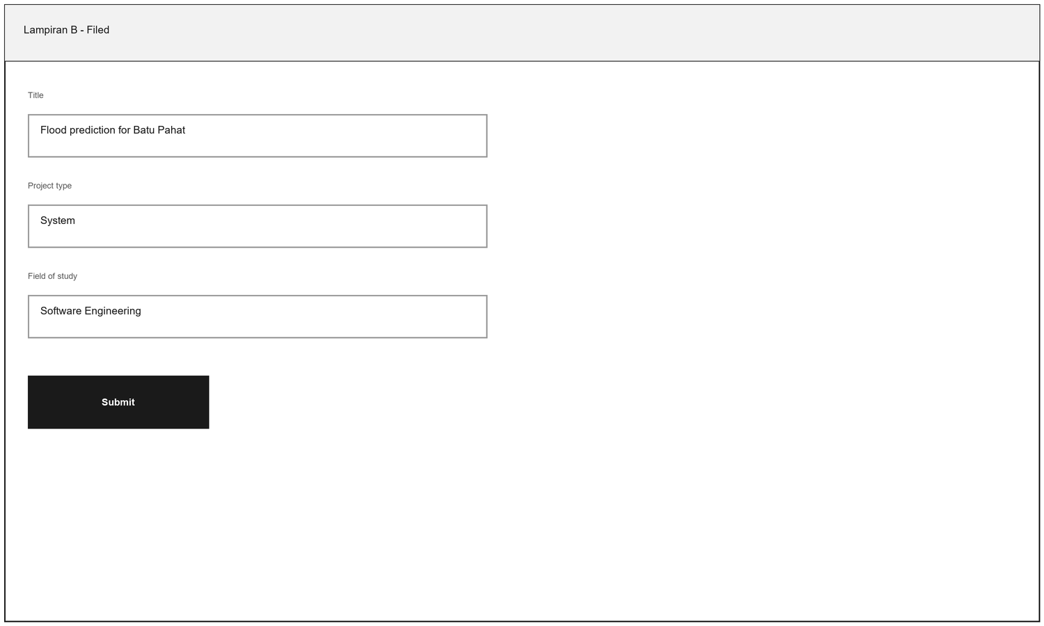
Figure 4.17: Lampiran B - Filed

4.3.4 Class Diagram
Figure 4.14 shows the twelve classes that carry the domain. A User is specialised into a StudentProfile or a SupervisorProfile. A StudentProfile is enrolled in a semester and registers one Project; a Project carries a chain of Milestones, the LampiranBForm filings and its Evaluation forms, and is attached to the SupervisionAssignment that names who supervises it. Each Evaluation holds one EvaluationScore per criterion, and those scores aggregate into the single FinalGrade, which is the number the pass mark is applied to.
The separation that matters most is between Project and Milestone: a project is the thing that has a title and a supervisor, and its milestones are the evidence that moves it forward. Nothing about a mark is stored on the project, because the mark is computed from the forms every time and only the FinalGrade is written.
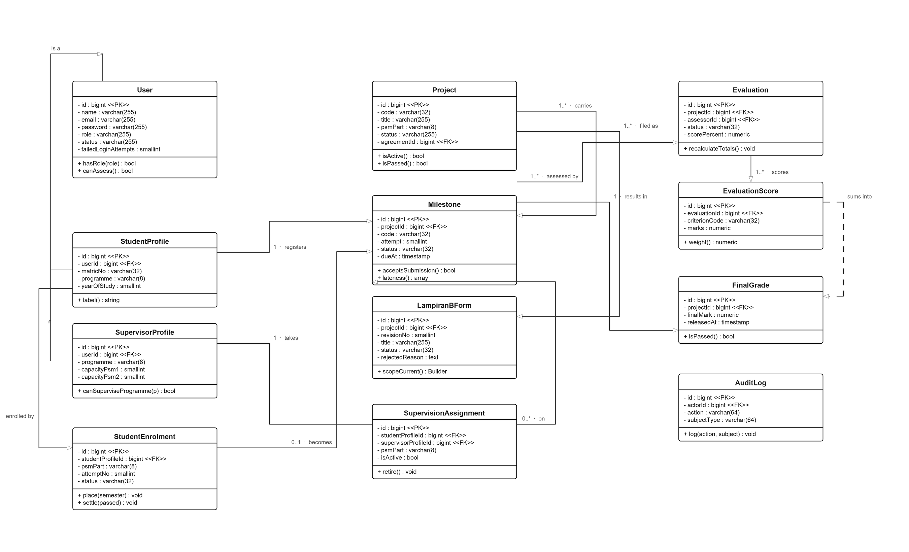
Figure 4.14: Class Diagram

